Choose the letter of the correct answer. In all cases, NOTA means “none of these answers”.

1. When Mr. Wonka decided to give the tour of his marvelous factory, he sat down with a map to plot his course. Which of these maps is a function?
A)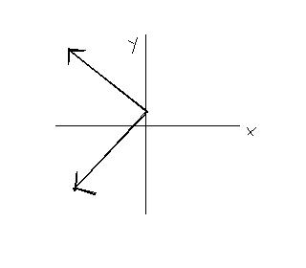 B) 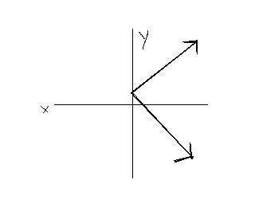 C)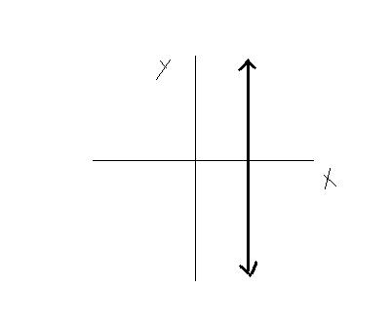
D)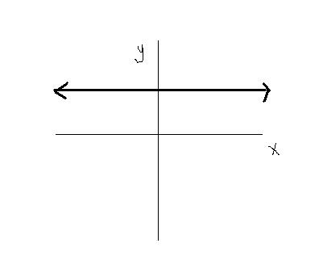 E) NOTA

2. Contrary to popular belief, the Golden Ticket isn’t flat. It actually is a rectangular prism. The length is 12 cm, the height is 7cm, and the entire volume is 42 square cm. What is the width?

A) 6 cm B) 2 cm C)  cm D) cm E) NOTA

3. Charlie’s parents could barely afford to buy Charlie one Wonka Bar because they were severely in debt. Evaluate the expression below to see just how much in debt Charlie’s parents really were (in thousands).
3+ (-2)-9+6-7+1-(-6)-18

A) -32 B) -20 C) -19 D) -18 E) NOTA

4. Augustus Gloop eats an average of 8 Wonka Bars in one day. If each bar is 1000 calories, how many calories from Wonka Bars does he consume in 10 weeks?

A) 7,000 B) 8,000 C) 56,000 D) 560,000 E) NOTA

5. Violet Beauregard is a champion gum chewer. Multiply the exponent below to find out how many pieces of gum she chewed on one of her average gum chewing days.

| (998 - 1000)² + (2 - 5)³ + (313,000 – 406,000)⁰ |

- 4 B) 22 C) 24 D) 32 E) NOTA

6. Veruca Salt only feels the need to allow her lofty presence with certain people. What is the property used to describe A+ (B+ C) = (A + B) + C?

- Commutative B) Distributive C) Associative
D) Substitution E) NOTA

7. Mike Teavee credits his golden ticket to simple algebraic equations, that when solved gave him the coordinates for the 4th golden ticket. Given the following system of equations find the coordinates of the ticket.
3x – 5y= -16
2x + 5y = 31

- (5, 3) B) (-3, 5) C) (-5, 3) D) (3, 5) E) NOTA

8. As you know Oompa- Loompa’s aren’t exactly the tallest people. The tippy-top of an Oompa-Loompa can be assigned the ordered pair (5,3) and the bottom of his foot (, 3). What is the distance from the tippy-top of his head to the bottom of his foot, along a straight line?

- 5.5 units B) 4.6 units C) 4 units
D) 5 units E) NOTA

9. Mr. Wonka has decided he wants a triangular piece of chocolate for wall art. It is to be a right triangle with one of its legs measuring 60 feet and the hypotenuse 100 feet long. Find the length of the other leg of the triangle in feet.

- 60 B) 80 C) 117 D) 160 E) NOTA

10. Augustus Gloop was a rather poor math student. All the time he spent eating chocolate made it hard to finish his math homework. While touring the factory, he was wondering exactly what a monomial was. Which of the following is a monomial?

- B) c + d C) 6 + i D) -6a E) NOTA

11. To get into Mr. Wonka’s extraordinary room of candy-goodness, he first needs the key. The particular key he needs is in the shape of a parabola. Which of the following pictures is the choice he needs?

- 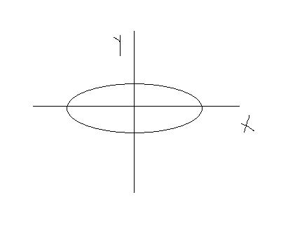 B. 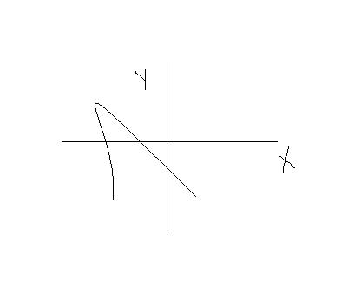C. 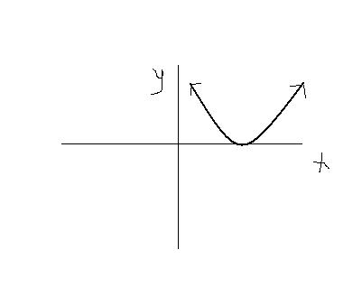
D. 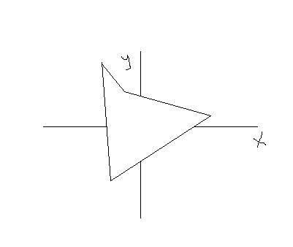 E. NOTA

12. Charlie, even when he was in the factory, felt excluded from the four other obnoxious, bratty, and greedy children. State the excluded values of

x² - 5x - 6
x² - 5x + 6

- {-1, 6} B) {1, 3} C) {0, 2} D) {2, 3} E) NOTA

13. Willy Wonka had father issues in the movie version of Roald Dahl’s beloved book Charlie and the Chocolate Factory. Who is considered the Father of Algebra?

- Euclid B) Archimedes C) Al-Khwarizmi
D) Hypathia E) NOTA

14. Like a “melt in your mouth” Wonka Bar, this radical equation contains everything to make it a perfect blend of sweetness. Find all solutions for the following radical equation:
√ x + 2 = x – 4
- {2} B) {2, 7} C) {7} D) {0, 7} E) NOTA

15. Charlie entered Willy Wonka’s candy land and it was far better than anything he could have imagined. Which of these is an imaginary number?

- 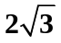 B) 0 C) 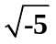 D) 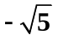 E) NOTA

16. When Augustus Gloop was sucked into the chocolate extractor the tube was angled. If the extractor is the point ( 7, 1 ) and the bottom is the point ( 1, 9 ), then what is the slope of the extractor?

- 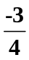 B)  C)  D) 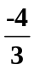 E)NOTA

17. In Wonka’s factory you can find an assortment of odd candies to satisfy your sugary needs. Charlie’s favorite type of candy was the Toffee-Apple Tree. So, simplify this expression:

( √ 14 + √ 3 ) ( √ 6 - √ 7 )

A) 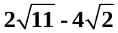 B) 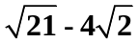 C) 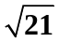 D) 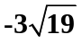 E) NOTA

18. The Oompa Loompas in the chocolate factory only want to use the purest and most natural sugars for their famous candy. Which of these is the set of Natural Numbers?

- {0, 1, 2, 3, 4, …} B) {…, -3, -2, -1, 0, 1, 2, 3, …}
C) {1, 2, 3, 4, …} D) {0, 1, 2, 3, …} E) NOTA

19. When Violet’s selfishness caused her to turn into a spherical, abnormally large blueberry, the Oompa Loompas weren’t sure if they would be able to roll her through the door. Find the equation of the line if Violet is rolled along the path from (-4, 6) to (-8, 10).

- x + y = 2 B) x + y = 10 C) x – y = 2 D) x – y = 10 E) NOTA

20. As the Oompa Loompas were rolling the bulbous Violet Beauregard out of the bubblegum room, one mathematically inclined Oompa Loompa thought about a problem as they passed by a roll of candy foil. Multiply the following polynomials and write your answer in simplest form :
( 4x + 9 ) ( 2 - 5x + 3 )

  - 6 - 2 - 33x B) 8 - 2 - 33x + 27 C) 8 + 27
- 8 - 33x + 27 E) NOTA

21. Willy Wonka was one radical man, so he came up with this problem about radicals. Multiply and then simplify this pair of radicals:

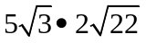

- 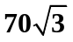 B) 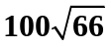 C) 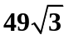 D) 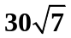 E) NOTA

22. Veruca Salts always felt that everyone else was not equal to her, due to her lofty status. Solve for t in Veruca’s inequality.
17t + 9 + () > 3 (8t + 7)

- t > 0 B) t < 0 C) 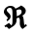 D)  E) NOTA

23. Suppose that the amount of sugar (in grams) in a chocolate bar ( x ) varies directly with the number of Wonka candy bars sold in a minute ( y ). When 124 grams of sugar are put into a chocolate bar, 4 bars are sold per minute. Write the given information as a direct variation equation that relates x and y.

- 124 = 4k B) 4 = 124k C) y = 31k D) y = 496
E) NOTA

24. When Veruca Salt decided to be a greedy little girl by demanding a squirrel for her own. The room she was in sloped toward the nut discarding hole with the points ( 7, 6 ) and ( 2, -3 ). Find the slope of the line perpendicular to the room Veruca was in.

- 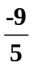 B) 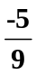 C) D) E) NOTA
25. Five chocolate bars and 2 nougat bars have a total of 6 grams of love, and 9 chocolate bars and 2 nougat bars have a total of 22 grams of love. How many grams of love are in each chocolate bar?

- 7 B) 6 C) 5 D) 4 E) NOTA

26. Mike Teavee was 60 inches tall and his feet were 12 inches long before he shrank. After he shrank, Mike was 12 inches tall. If his body is proportional to what it was before he shrank, find the length of his feet, in inches, after he shrank.

A) 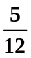 B) 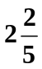 C) 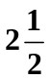 D) 60 E)NOTA

27. If the area of a Scrumdiddlyumptious Bar is + 5r – 24, find the lengths (in binomials) of the sides of the chocolate bar.

A) ( r + 8 ) ( r – 3 ) B) ( r – 6 ) ( r + 4 ) C) ( r – 8 ) ( r + 3 )
D) ( r + 6 ) ( r – 4 ) E) NOTA

28. At the end of the tour of the factory Willy Wonka reveals to Charlie that his prize will be to own all of Wonka’s company and property. Simplify 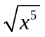, x > 0

- 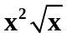 B) x C) 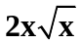 D) 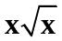 E) NOTA

29. Willy Wonka wants to know how many chocolate bars are eaten per day. Help him by simplifying this expression:
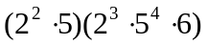

- 2⁵ ∙ 6 ∙ 5³ B) 2⁵ ∙ 5⁵ ∙ 6 C) 2⁶ ∙ 5⁴ ∙ 6 D) 2 ∙ 5³ ∙ 6 E) NOTA

30. When Charlie was in the chocolate factory he was considered a zero, now he is a hero! Which of the following is always equal to zero?
  - ii. 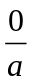 iii. 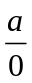 iv. 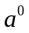

- i and ii B) i and iii C) ii and iii D) all of the above
E) NOTA

